DriverPass System Design Document
Thomas Fronteddu | CS-255 | Project Two

UML Diagrams

UML Use Case Diagram
The use case diagram below identifies the actors who interact with the DriverPass system - Customer, Secretary, Driver, IT Officer (Ian), Owner (Liam), and the DMV as an external system - along with the core use cases each actor performs, including account registration, lesson scheduling, practice testing, password resets, activity reporting, and DMV compliance updates.
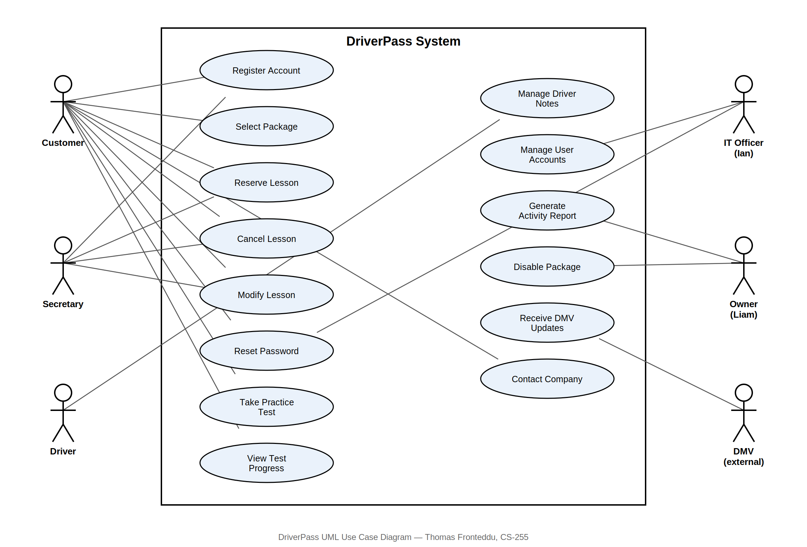
Figure 1: DriverPass UML Use Case Diagram

UML Activity Diagrams
The first activity diagram below breaks down the Register Account use case, including the decision point for validating a customer's payment information before an account is created. The second breaks down the Reserve Driving Lesson use case, including the decision point for checking driver and car availability before a reservation is confirmed.
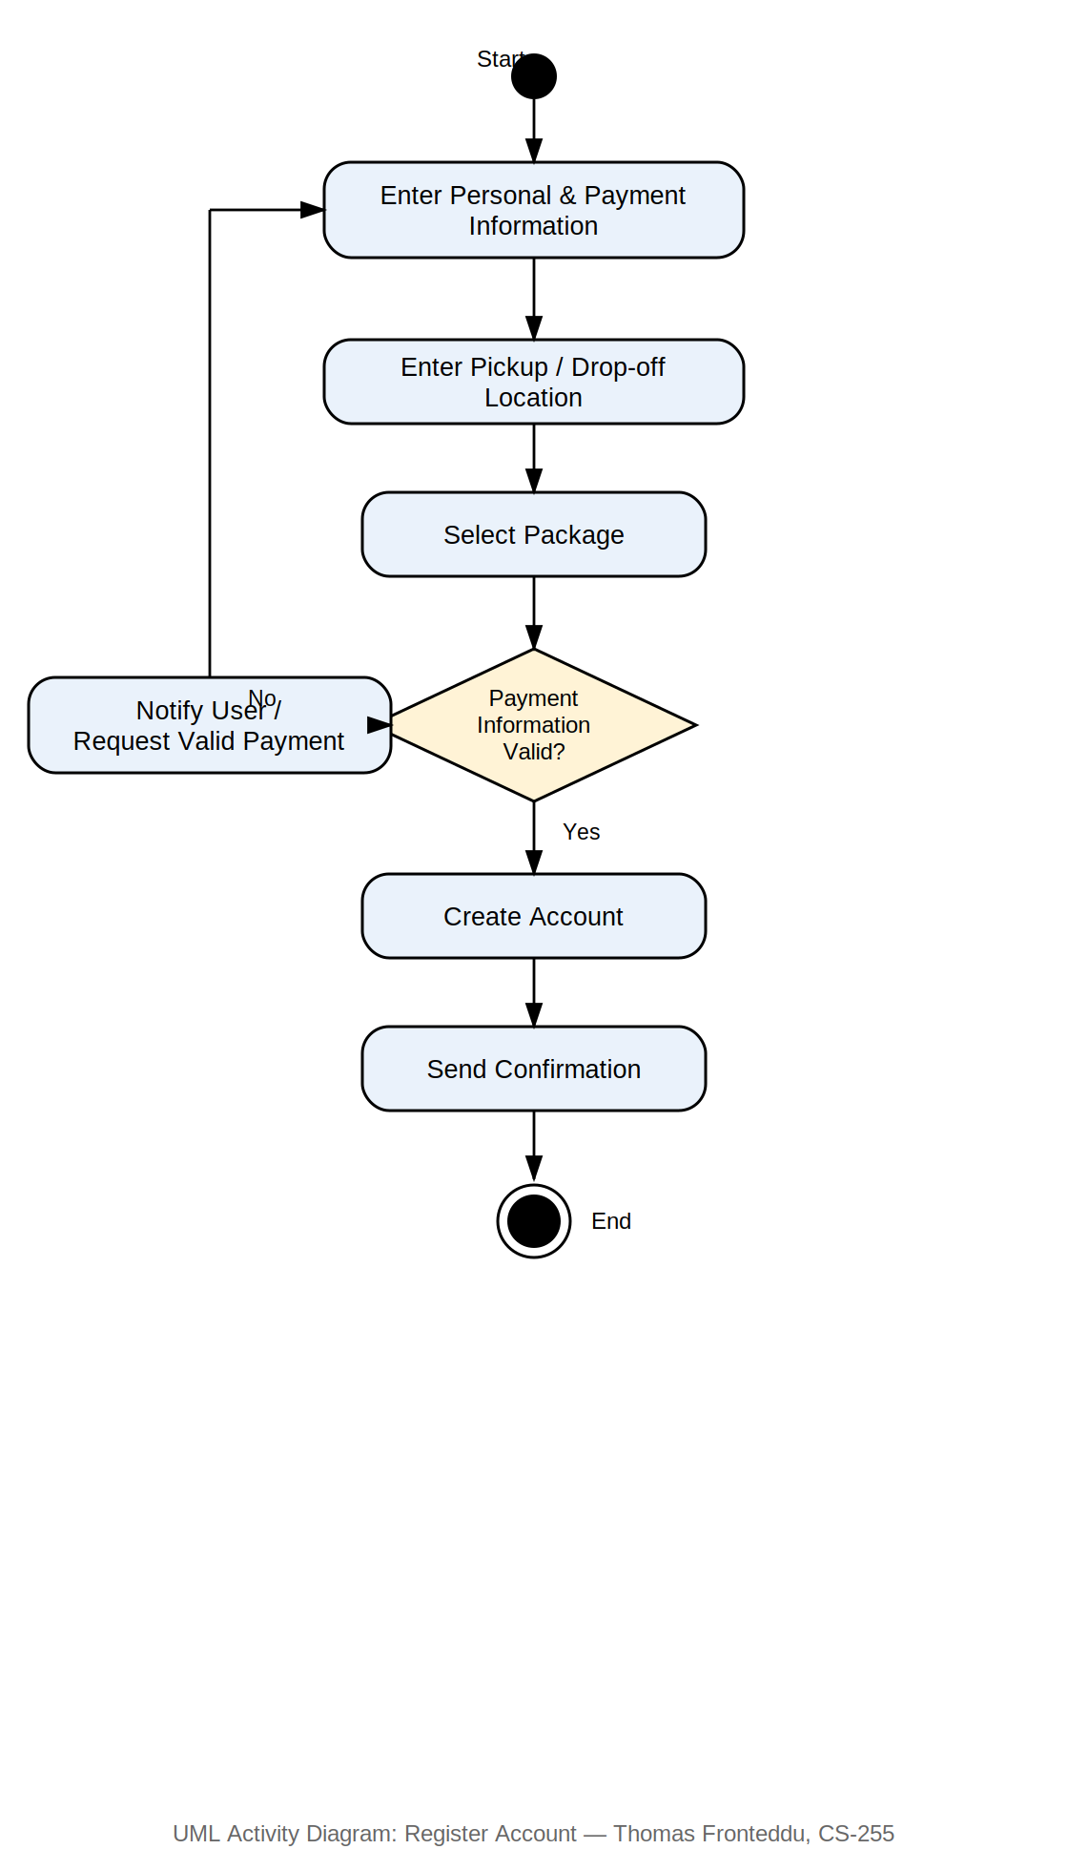
Figure 2: UML Activity Diagram - Register Account
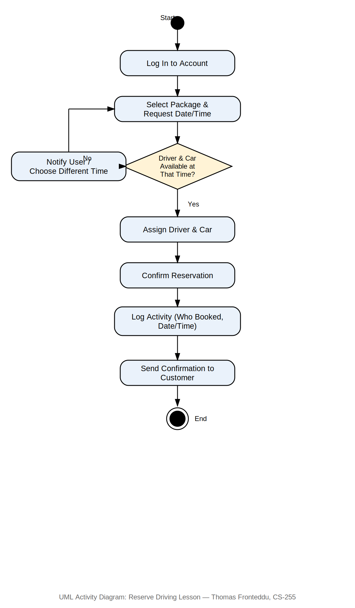
Figure 3: UML Activity Diagram - Reserve Driving Lesson

UML Sequence Diagram
The sequence diagram below illustrates the interactions involved in the Reserve Driving Lesson use case, showing the messages exchanged between the Customer, the DriverPass System, and the Activity Log when a reservation is requested, including the alternate paths for when a driver and car are available versus unavailable.
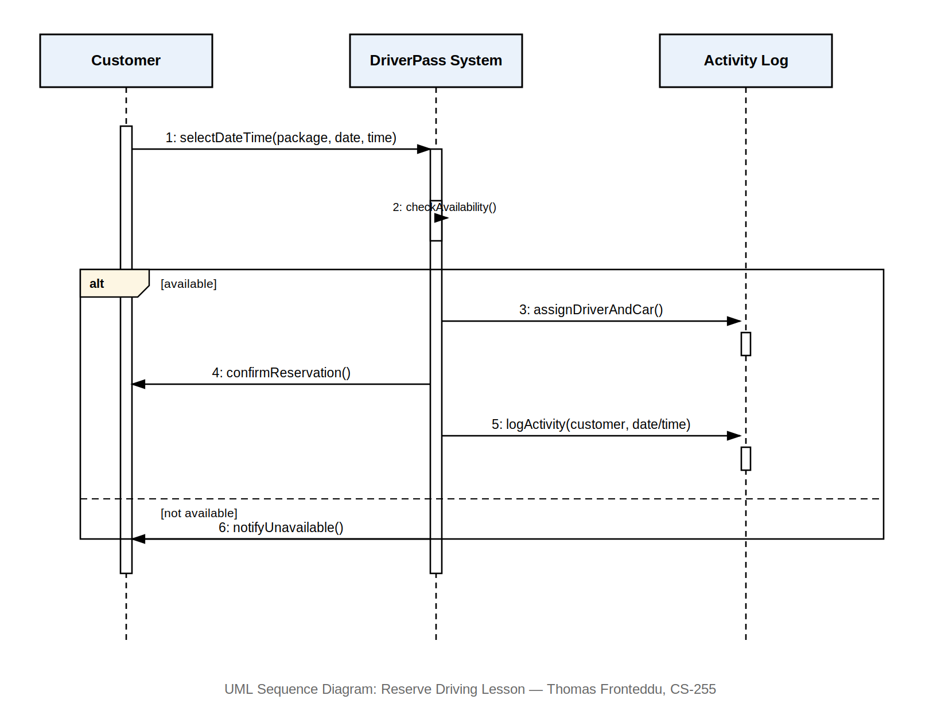
Figure 4: UML Sequence Diagram - Reserve Driving Lesson

UML Class Diagram
The class diagram below models the core classes needed for the DriverPass system. User is the base class for Customer, Secretary, Driver, and Employee (which represents both Liam and Ian, distinguished by role). Additional classes capture Package, Lesson, Car, PracticeTest, ActivityLog, and DMVUpdate, along with the relationships between them.
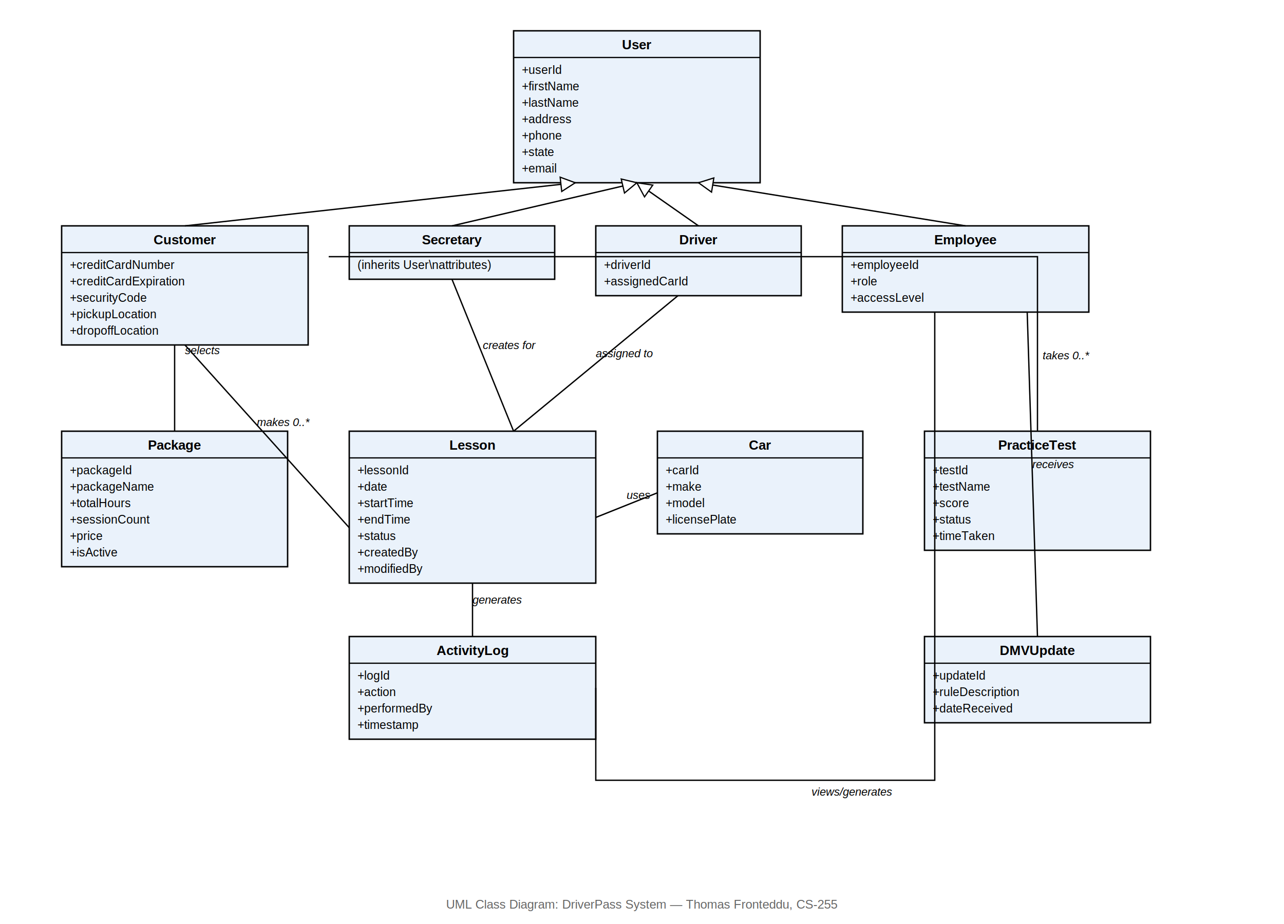
Figure 5: UML Class Diagram - DriverPass System

Technical Requirements
Based on the diagrams above and the needs DriverPass expressed during the requirements interview, the following technical requirements describe the hardware, software, tools, and infrastructure necessary to support this system design.

Hardware
- Client devices: The system must be accessible from desktop computers, laptops, and mobile devices, since Liam wants to access data from any computer or mobile device, and customers need to schedule and manage lessons online from wherever they are.
- Server infrastructure: Since the system will run on the cloud, DriverPass does not need to purchase or maintain its own physical servers. Cloud-hosted virtual servers will handle application processing, database storage, and backups.

Software
- Cloud-hosted web application: Ian specified that the system needs to run off the web, preferably over the cloud, so that DriverPass does not need to manage backup and security themselves.
- Relational database management system: A database is needed to store customer, lesson, package, driver, car, practice test, and activity log records, and to support the reporting Liam requested for tracking who booked, modified, or canceled a reservation.
- Role-based access control software layer: Since Ian needs full administrative access while customers and the secretary need more limited access, the system requires an authentication and authorization layer that enforces different permission levels for each user role.
- DMV integration interface: The system needs a way to receive updates from the DMV (new rules, policies, or sample questions) and trigger a notification when an update is received, keeping practice tests and training material current.

Tools
- Development and design tools: UML modeling tools (such as Lucidchart) to maintain and update the system's design diagrams as DriverPass's needs evolve.
- Reporting/export tools: The ability to export reports and data (for example, to Excel) so Liam can review information offline, per his request to work on downloaded reports at home.

Infrastructure
- Online/offline data access: The system must let users view data both online and offline, but only allow data to be modified while online, to avoid data redundancy across multiple servers, per Ian's explicit requirement.
- Scalable, flexible package structure: While adding or removing entire packages requires a developer, the system must at minimum allow Liam to disable an existing package so it is no longer available for new registrations.
- Security and backup infrastructure: Since DriverPass wants to focus on running their business rather than managing technical concerns, the cloud infrastructure must handle data backup, security patching, and system availability without requiring DriverPass staff to manage it directly.

